Project Design Phase-II
Technology Stack (Architecture & Stack)

Date | 26 June 2026
Team ID
Project Name | Student Leave Request Management
Maximum Marks | 4 Marks

Technical Architecture:
The Deliverable shall include the architectural diagram as below and the information as per the table1 & table 2

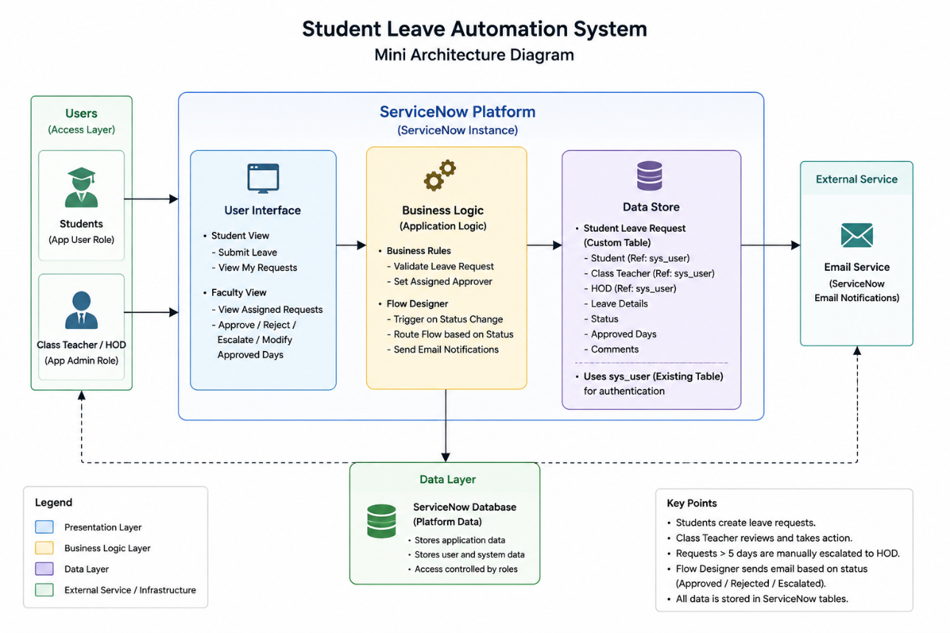

Table 1: Components & Technologies
S.No | Component | Description | Technology
1 | User Interface | Student View & Faculty View | ServiceNow Workspace / Forms / Lists
2 | Application Logic | Leave submission & validation | Business Rules
3 | Workflow Automation | Approval workflow & notifications | Flow Designer
4 | Database | User identities and leave requests | sys_user, Custom Leave Request table
5 | Email Service | Approval / Rejection / Escalation emails | ServiceNow Notifications
6 | Security | Role-based access | ACLs, x_leave_app.user, x_leave_app.admin
7 | Infrastructure | Cloud platform | ServiceNow Cloud

Table 2: Application Characteristics
Characteristic | Description | Technology
Security | Role-based access for students and faculty | ACLs, Roles
Scalability | Supports increasing leave requests and users | ServiceNow Platform
Availability | Available whenever the ServiceNow instance is online | ServiceNow Cloud
Performance | Flow-based processing and lightweight forms | Flow Designer
Reliability | Centralized leave records and notifications | ServiceNow Database

